Jiangsu Jin Fangyuan automation production line equipment
2015-12-25 Jin Fangyuan, Jiangsu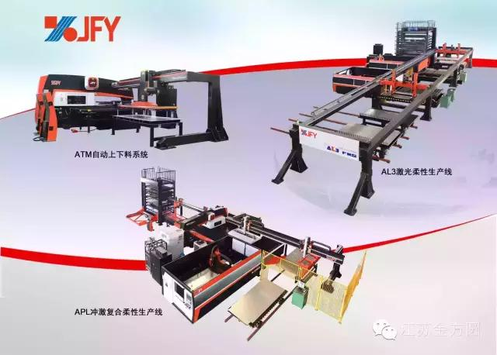
2016 will be a metal sheet metal processing industry is a challenging year, along with the popularity of the 4 industry "concept, compared with the processing method of automatic production line processing mode with the traditional advantages of the There is nothing comparable to this and has made considerable development, and play a more and more important role in the process of industrialization.
With rising labor costs, optimization and upgrading of industrial technology, also led to the sheet metal processing equipment, automation, intelligent and flexible development, bending robot, punch blanking production line and flexible production line of laser cutting and laser cutting and stamping, bending, welding and logistics, intelligent sheet metal factory, has usher in a new opportunity.
Jiangsu golden circle has adapted to the new demand of the market, and has developed intelligent equipment such as ATM-6 automatic loading and unloading production line, impulse compound flexible production line, CNC laser cutting flexible production line and so on.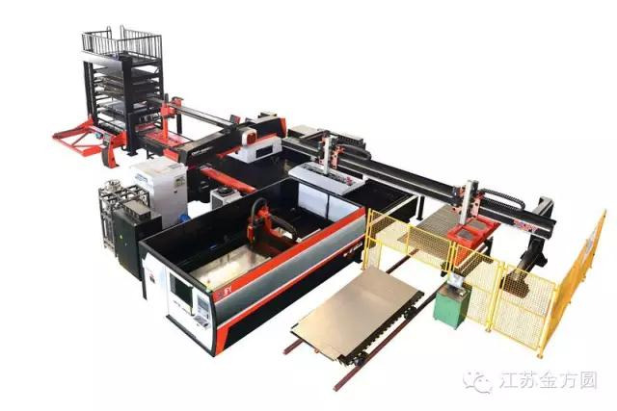
Flush composite flexible production line
The production line adapts to the high intelligentized production requirements. The equipment consists of a punch press and a laser cutting machine, a storehouse system, an upper and lower feed system and a central control system. It can complete a series of automatic production processes, including plate storage, outgoing storage, automatic feeding, punch processing, laser cutting and automatic blanking. It is fast, accurate and reliable, and can customize all kinds of special flexible production lines for customers.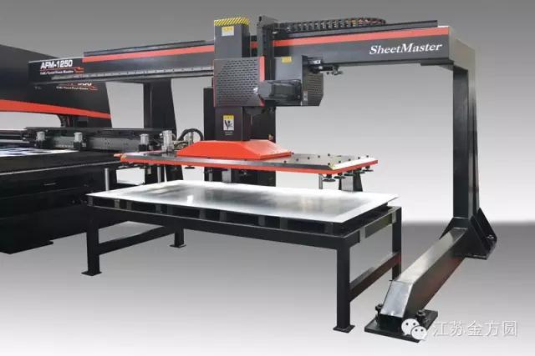
Automatic feeding system for CNC turret punch press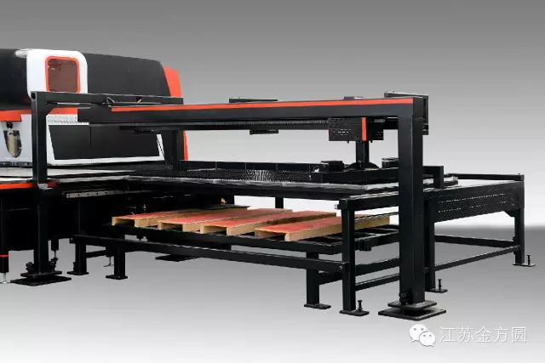
Automatic blanking system for CNC turret punch press
The modular design of the upper and lower cutting mechanism can be combined with our series of turret punch press to facilitate the customer's upgrading needs of the purchased products. Raw material information, sheet processing quantity and other data at a glance, strengthen the management of materials. The whole machine can realize full automatic cycle processing, greatly improving production efficiency and reducing labor intensity. The automatic feeding device is provided with a magnetic layer, a double edge, blowing, detection and other functions, to ensure the reliability of the whole material feeding action, only 18 seconds to complete. The feeding mechanism is driven by the servo motor, and the pneumatic clamp is combined with the active worktable to realize the automatic palletizing work of the blanking plate.

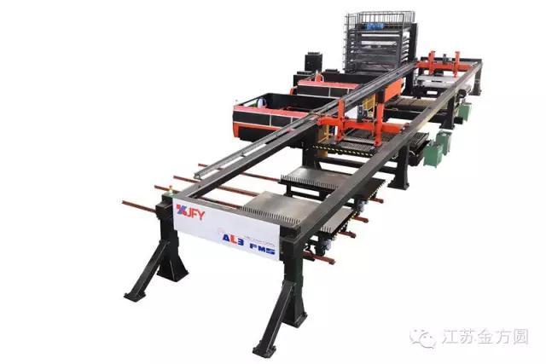
Numerical control laser cutting flexible production line
The production line is another new product developed by Jin Fangyuan, Jiangsu. It is made up of two or more CNC laser cutting machines, storehouse system, up and down material system and central control system. It can complete a series of automatic 24 hours continuous production process from the sheet to the warehouse, out of the warehouse to automatic feeding, cutting and automatic feeding.
In 2016, Jin Fangyuan, Jiangsu, will start a new voyage, and join hands with you to create a new brilliance!

